Child Protection Policy for Children
2017 – 2018

What does Child Protection mean?
At Moorthorpe Primary School all of the adults around you think that your health, safety and welfare are very important. In our school we respect our children and want to keep them safe and help protect their rights.
We do our best to help children make good educational progress.
We teach children how to recognise risks in different situations and how to protect themselves and stay safe.

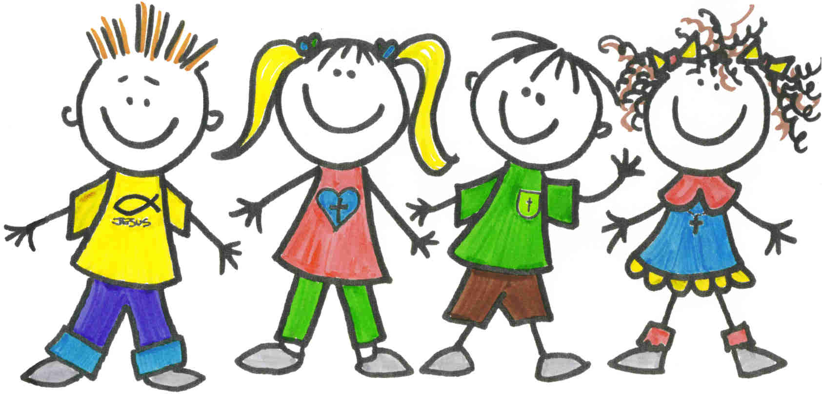

How will we protect you?
We try to provide a safe environment for children to learn in.
We want to ensure that children remain safe, at home as well as at school.
We think it is important for children at Moorthorpe Primary to know where to get help if they are worried or unhappy about something.
If you need to talk – we will listen!
You can talk to any adult in school
It is Miss Hudson’s special job to keep you safe – talk to her (or an adult in school that you trust) if you are worried.
Put something in the worry box.
Don’t keep it a secret if…..
Someone is upsetting you.
Someone is saying funny things that you do not like or makes you sad.
Someone is touching you where they shouldn’t.
Someone is trying to give you tablets, cigarettes, drugs or alcohol.
Hitting or hurting you.
Someone is sending unkind messages on the internet or to your phone.
Let someone know!

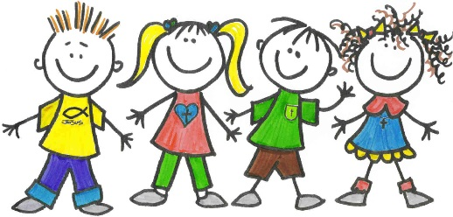
Worry Box Slip….

Your Name:
Your Class:
Your Worry:

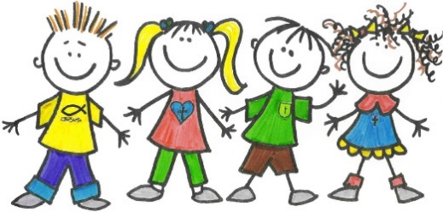
Worry Box Slip….

Your Name:
Your Class:
Your Worry:

.Worry Box Slip….

Your Name:
Your Class:
Your Worry:

