Below are a range of resources containing important information relating to Wakefield Families Together, Family Hubs and the Team Around the School. Schools can share this information with parents and families via school websites, social media pages, parenting apps, text messages, bulletins, posters – and/or any other creative way!
All the information in this resource pack is simple, specific and ready to use or adapt; in the hope that the increase in promotion and engagement across Wakefield will enable families to become more familiar with Wakefield Families Together, schools have the information accessible for families to access before the point of concern, and so parents can ask for help at an earlier point.

Add information to your School’s Website: The text below can be used on your school’s website to promote Wakefield Families Together. We would love this to be added to its own ‘Wakefield Families Together’ section, or if there is a relevant ‘parents support’ or ‘family support’ section.
Wakefield Families Together
Wakefield Families Together brings services together, so that it’s easier for you to find and access the support you need, at the earliest opportunity.
We want children, young people, and families to tell us they are happy, healthy, and safe. Wakefield Families Together are about working on your behalf so that if you have a concern about your child or family member, you only need to have one conversation with us, and we can direct you to the right support. You can access this support through your child’s school, family hub, or in the local community.
To help us localise how we work with families across the Wakefield district, we have grouped our teams and partner organisations into six community ‘cluster’ areas, with nine family hubs and three Youth Hubs. You can find your local Family Hub or Youth on the Wakefield Families Together website here: Family Hubs – Wakefield Families Together and here: Youth Hubs – Wakefield Families Together
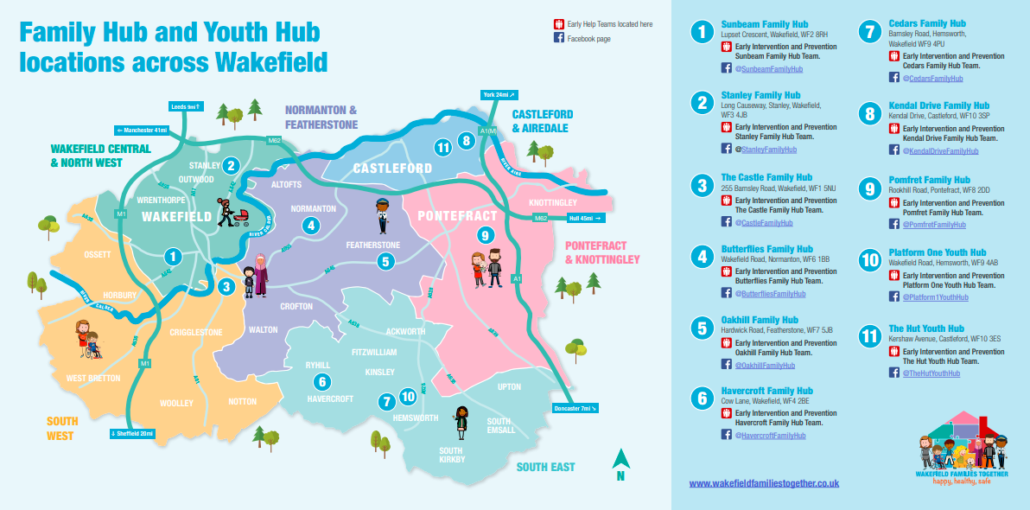Everyone needs help and support at some point in their life. So, when you do and find it hard to deal with a difficult situation, or have worries around family relationships, behaviour, school attendance, emotional and mental health, domestic abuse, parental conflict, housing issues, or employment and debt problems, Family Hubs can help direct to the right people and services.
Sometimes the concerns you have may need a group of professionals to come together to build a package of support with you and other family members so that we have the right expertise to help the whole family. Find out more about the Team Around the School model here: The ‘Team Around’ approach – Wakefield Families Together
Website: www.wakefieldfamiliestogether.co.uk
Contact: Wakefieldfamiliestogether@wakefield.gov.uk

What’s on Guides:
We want schools to promote their local Family Hub’s ‘What’s on Guides’ you can find the latest version on the Wakefield Families Together website here:
- Family Hubs – Wakefield Families Together
- Youth Hubs – Wakefield Families Together
Please add the relevant Family Hub What’s on Guide link to your school’s website or contact your local Family Hub for further information.

Videos: If you wish to add the TAS and the TAEY videos to your website, you can do so via adding the below links:
TAEY – Team Around The Early Years - YouTube / https://www.youtube.com/watch?v=QkwgSphK4SQ
TAS - Team Around The School - YouTube / https://www.youtube.com/watch?v=9fry3xTlc6o

Bulletin
Please help by sharing the attached bulletin any (or all!) of the following ways:
- On your school’s website – under the ‘parenting support’ sections, or similar
- On the walls of your school – simply print the document and pop this up in accessible areas within the school!
- On your social media platforms as an image or link to the website
- Via parenting boards, texts or apps – or whatever way you communicate to parents!

Leaflets:
- EIP Worker 1 minute guide
- Link SW 1 minute guide
- Parent and carer leaflet – TAS
- Parent and carer leaflet – TAEY
- Parent and carer TAS and TAEY leaflets in Polish and Urdu
The above leaflets that are accessible on the WFT page of the Traded Services Website to download as a zip file.
- Young person TAS leaflet – attached below
This new leaflet was co-produced with young people, some of whom have been discussed at TAS previously and may be in receipt of support.
The way to use this new resource is that when a member of school staff is discussing TAS with a young person, this leaflet will help to explain what TAS is and what support it may result in for the young person and the family.
The completed form should be provided to your TAS lead along with the TAS Request for Support form so that it can support the discussion at TAS, enabling feedback to the young person regarding the outcome, based on their identified needs.

Poster for school buildings: print and display around the school

Social Media Text and Graphics
Please use the attached social media text graphics on your school’s social media pages (Facebook, Twitter, Instagram etc.) to promote Wakefield Families Together, Family Hubs and Team Around the School. When sharing the graphics, please add reference to the Wakefield Families Together Website. www.wakefieldfamiliestogether.co.uk

Website promotion:
This is the QR code to the Wakefield Families Together Website: https://www.wakefieldfamiliestogether.co.uk
You can add this to any leaflets, flyers, support tools that go out to parents / carers and families.

