
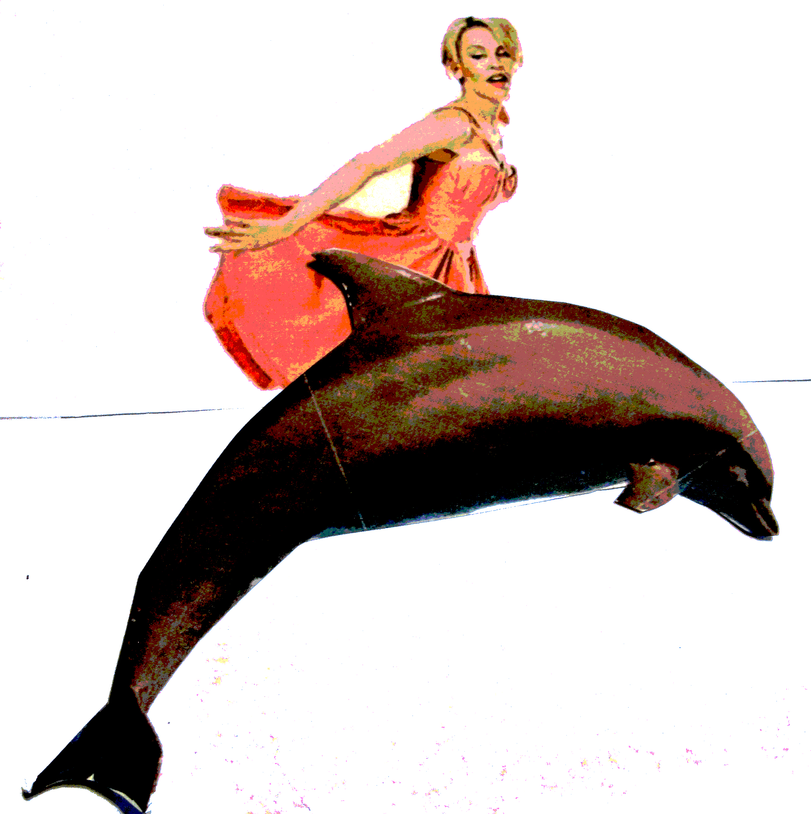

- Dolphins are one of the smartest animals in the world.
- You can train them to do tricks by giving them treats.
- The dolphins originated from North America.
- They were trained at Westfield baths in Elmsall to learn new tricks to thrill audiences at Flamingoland.
- The dolphins were trained there between 1972-1974.
- The old baths were bought by Mr John Nolan who trained dolphins there each winter.
- In the summer the dolphins preformed shows all over the UK.
- No one knows for sure how many dolphins were kept at the pool, but our research tells us that there were never more than six.
- We have found this information by searching the internet and posting a brief advertisement in the local newspaper .
- Also got some of the information by writing to a firm who specialize in collecting old newspapers called the Yorkshire Post .
- We have had information from people who remember the dolphins including an old lady aged 94 called Gladys Springer, who told us that they used to charge a small fee to go in and play with the dolphins.
By Taylor Goodwin

